C:\Users\b.matthews\AppData\Local\Microsoft\Windows\Temporary Internet Files\Content.IE5\6FQ8DR8N\MC900412476[1].wmfC:\Users\b.matthews\AppData\Local\Microsoft\Windows\Temporary Internet Files\Content.IE5\6FQ8DR8N\MC900412476[1].wmf

**Flower Power**

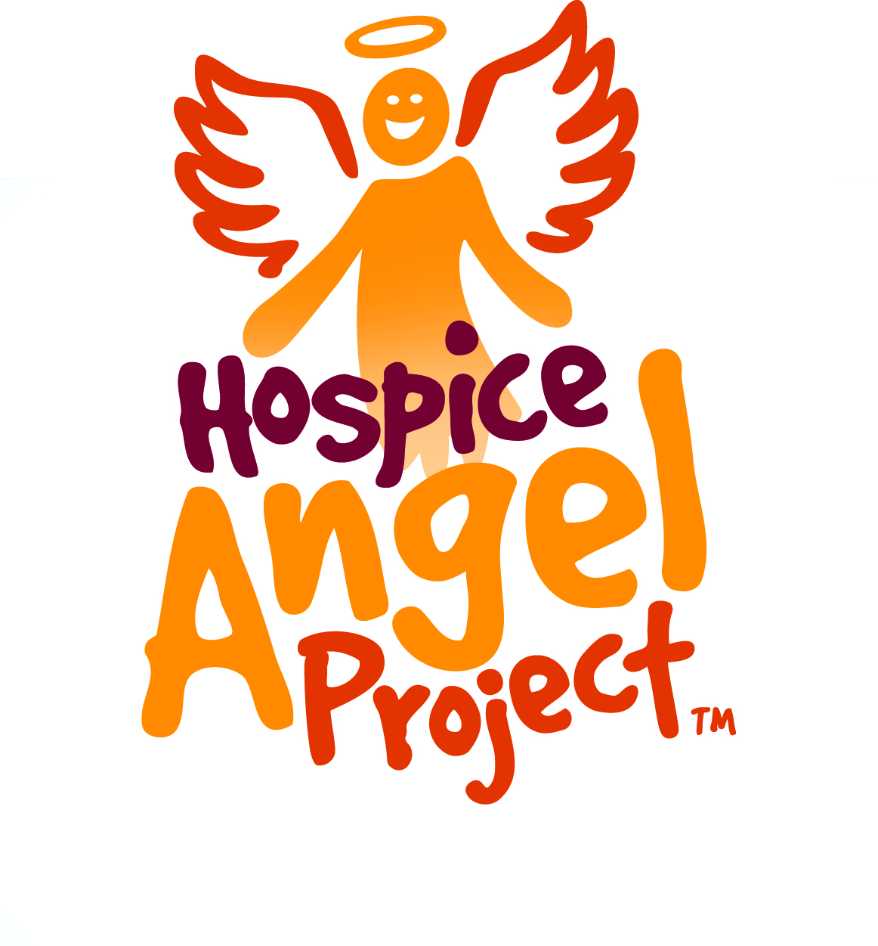[](http://www.hospice.co.nz/)



**Alfriston College in partnership with Totara Hospice South Auckland**

Over the next three days, you will experience the joy of supporting an important charity in our community.

What is Hospice?

Totara Hospice South Auckland has been meeting palliative care needs of the South and the South East Auckland community now for 30 years. Through the Totara Foundation, Totara Hospice South Auckland is able to provide free of charge care and support for families/ whanau of any person living with a life limiting illness in our community.  
  
Totara Hospice South Auckland is a supportive and caring organisation based on a philosophy of care rather than a destination, as commonly thought. The majority of Hospice care is based in the community, delivered by our Community Palliative Care Nursing team. For greater care needs an In-Patient Unit - Totara House based in Manurewa is avaliable to any person requiring care regardless of age, illness, ethnicity or need and this care is delivered 24 hours 7 days a week by our skilled IPU team.

Totara Hospice South Auckland currently provides:

* 9 inpatient beds which are used for respite, symptom control or end of life care
* Community Palliative Care Nursing Services
* Family Support Services, Counselling and Social Work
* Day Stay facilities
* Ambulatory Care facilities for day procedures and clinics
* Complementary therapies including massage, physiotherapy, etc.

Learners will be able to:

Tech curriculum…….

**Context:** **Using creativity, learners are to develop floral arrangements to sell and show our appreciation of the community Hospice.**

Initial Planning: (What do I know already?)

What do I need to do, know? (Information gathering includes identifying skills, knowledge needed, resources, people to consult etc.)

Possible constraints and tensions: (e.g timeframes, costs, social, technical)

**Brief Development:**

**Stakeholder Information:**

Direct: (who do you think are the main stakeholders for your product could be?)

Indirect: (Who else might be affected by the development of your bouquet?)

**Technologist Questions: Florist 1**

1. How do you decide what you are making?
2. What planning do you do before making a bouquet?
3. How do you know what resources you need?
4. When making a bouquet, how do you evaluate it?
5. What does a bouquet need to be to be successful?
6. What skills do you need to be a successful florist?

**Technologist Questions: Florist 2**

1. How do you decide what you are making?
2. What planning do you do before making a bouquet?
3. How do you know what resources you need?
4. When making a bouquet, how do you evaluate it?
5. What does a bouquet need to be to be successful?
6. What skills do you need to be a successful florist?

**Technologist Questions: Florist 3**

1. How do you decide what you are making?
2. What planning do you do before making a bouquet?
3. How do you know what resources you need?
4. When making a bouquet, how do you evaluate it?
5. What does a bouquet need to be to be successful?
6. What skills do you need to be a successful florist?

**Planning:**

|  |  |  |
| --- | --- | --- |
| Session Date and Time | What am I going to do? | How did I go? |
| Monday 20th:  Session 1 |  |  |
| Session 2 |  |  |
| Session 3 |  |  |
| Tuesday 21st  Session 1 |  |  |
| Session 2 |  |  |
| Session 3 |  |  |
| Wednesday 22nd  Session 1 |  |  |
| Session 2 |  |  |
| Session 3 |  |  |

**My intended outcome:**

What am I making?

Why am I making a bouquet?

Where will my bouquet be used?

What attributes does my bouquet need to have?

What are possible range of materials / plants my bouquet could be made from?

**Product Analysis:**

What physical attributes did my bouquet have? (shape / size / texture / colour)

Which parts of my bouquet are functional? (size / structure / height / form) Paul is form the right word for how it stays together???

**Reflecting on my outcome:**

Here is the outcome I have produced:

Place a photo here

Does my outcome address the brief? YES NO

Does it meet the requirements for the key attributes? YES NO

If it does meet the requirements, how does it meet them?

If it does not meet the requirements, what requirements are not met and why?